4.Normalization:

Order:(C_Id,Name, Gender, Address, Email, Phone_Number, P_Id ,

Product_Name, Price,Meterial, Amount_in_Inventory )

1NF:Phone_Number Multivalued attribute

2NF:C_Id,Name, Gender, Address, Email, Phone_Number

P_Id , Product_Name, Price,Meterial, Amount_in_Inventory

3NF:No transitive dependency

C_Id,Name, Gender, Address, Email, Phone_Number

P_Id , Product_Name, Price,Meterial, Amount_in_Inventory

Tables from Order:

1.C_Id,Name, Gender, Address, Email, Phone_Number

2.C_Id,Phone Number-Composite PK

3.P_Id , Product_Name, Price,Meterial, Amount_in_Inventory

4.O_Id,C_Id,P_Id

Provide: (S_Id,Name,Address,Join_date,Phone_Number, P_Id ,

Product_Name, Price,Meterial, Amount_in_Inventory)

1NF:Phone_Number Multivalued attribute

2NF:S_Id,Name,Address,Join_date,Phone_Number

P_Id , Product_Name, Price,Meterial, Amount_in_Inventory

3NF:No transitive dependency

S_Id,Name,Address,Join_date,Phone_Number

P_Id , Product_Name, Price,Meterial, Amount_in_Inventory

Tables from Provide:

5.S_Id,Name,Address,Join_date,Phone_Number

6.S_Id,Phone_Number-Composite PK

7.P_Id , Product_Name, Price,Meterial, Amount_in_Inventory

8.Pr_Id,S_Id,P_Id

Pay:(C_Id,Name, Gender, Address, Email, Phone_Number,B_Id,

Total_Bill,Transaction_Date,Bill_Type)

1NF:Phone_Number Multivalued attribute

2NF:C_Id,Name, Gender, Address, Email, Phone_Number

B_Id, Total_Bill,Transaction_Date,Bill_Type

3NF:No transitive dependency

C_Id,Name, Gender, Address, Email, Phone_Number

B_Id, Total_Bill,Transaction_Date,Bill_Type

Tables from Pay:

9.C_Id,Name, Gender, Address, Email, Phone_Number

10.C_Id,Phone_Number-Composite PK

11.B_Id, Total_Bill,Transaction_Date,Bill_Type,C_Id

Receive:( B_Id,Total_Bill,Transaction_Date,Bill_Type,Cashier_Id,

Name,Gender,Address,Phone_Number,)

1NF:Phone_Number Multivalued attribute

2NF:B_Id, Total_Bill,Transaction_Date,Bill_Type

Cashier_Id,Name,Gender,Address,Phone_Number

3NF:No transitive dependency

B_Id, Total_Bill,Transaction_Date,Bill_Type,Cashier_Id

Cashier_Id,Name,Gender,Address,Phone_Number

Tables from Receive:

12.B_Id, Total_Bill,Transaction_Date,Bill_Type,Cashier_Id

13.Cashier_Id,Name,Gender,Address,Phone_Number

14.Cashier_Id,Phone_Number-Composite PK

Total Tables:

1.C_Id,Name, Gender, Address, Email, Phone_Number

2.C_Id,Phone Number-Composite PK

3.P_Id , Product_Name, Price,Meterial, Amount_in_Inventory

4.O_Id,C_Id,P_Id

5.S_Id,Name,Address,Join_date,Phone_Number

6.S_Id,Phone_Number-Composite PK

7.P_Id , Product_Name, Price,Meterial, Amount_in_Inventory

8.Pr_Id,S_Id,P_Id

9.C_Id,Name, Gender, Address, Email, Phone_Number

10.C_Id,Phone_Number-Composite PK

11.B_Id, Total_Bill,Transaction_Date,Bill_Type,C_Id

12.B_Id, Total_Bill,Transaction_Date,Bill_Type,Cashier_Id

13.Cashier_Id,Name,Gender,Address,Phone_Number

14.Cashier_Id,Phone_Number-Composite PK

Tables after Normalization:

1.C_Id,Name, Gender, Address, Email, Phone_Number

2.P_Id , Product_Name, Price,Meterial, Amount_in_Inventory

3.O_Id,C_Id,P_Id

4.S_Id,Name,Address,Join_date,Phone_Number

5.Pr_Id,S_Id,P_Id

6.B_Id, Total_Bill,Transaction_Date,Bill_Type,C_Id

7.B_Id, Total_Bill,Transaction_Date,Bill_Type,Cashier_Id

8.Cashier_Id,Name,Gender,Address,Phone_Number

Table 1:

create table Customer(

C_Id number(20),

Name varchar2(30),

Gender varchar2(10),

Address varchar2(40),

Email varchar2(20),

Phone_Number number(20))

alter table Customer add constraint Customer_pk primary key(C_Id)

alter table Customer modify (Name not null)

alter table Customer add constraint cust_pk unique(email)

desc Customer

select *

from all_constraints

where table_name='CUSTOMER'

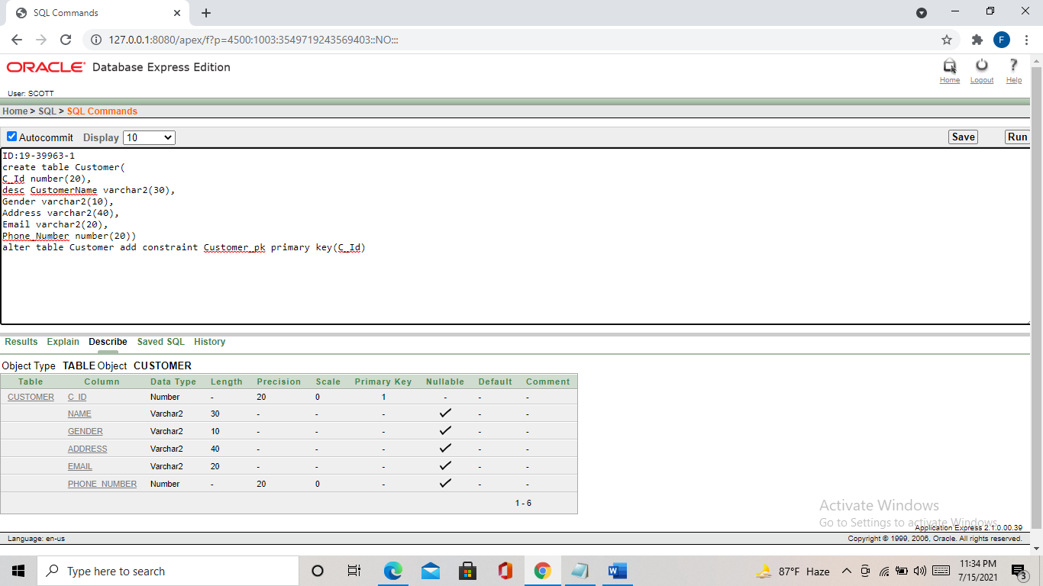

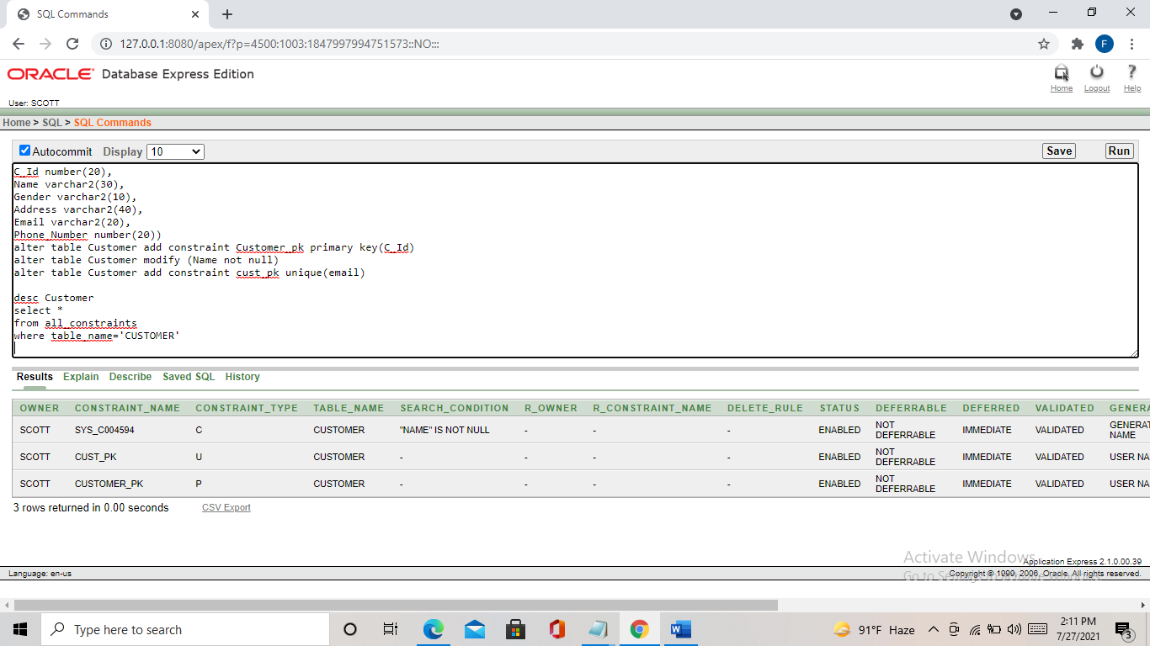

Table 2:

create table Product(

P_Id number(20),

Product_Name varchar2(30),

Price number(10),

Meterial varchar2(30),

Amount_in_Inventory number(20))

alter table Product add constraint Product_pk primary key(P_Id)

desc Product

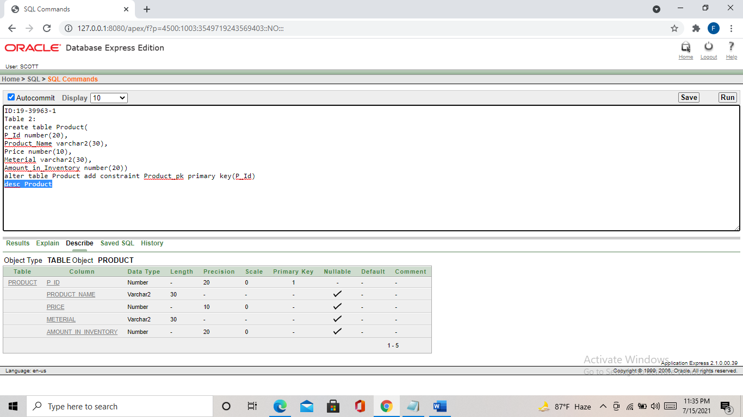

Table 3:

create table Ordeer(

O_Id number(20),

C_Id number(20),

P_Id number(20))

alter table Ordeer add constraint Ordeer_pk primary key(O_Id)

alter table Ordeer add constraint O_fk foreign key(C_Id) references customer(C_Id)

alter table Ordeer add constraint Or_fk foreign key(P_Id) references product(P_Id)

desc Ordeer

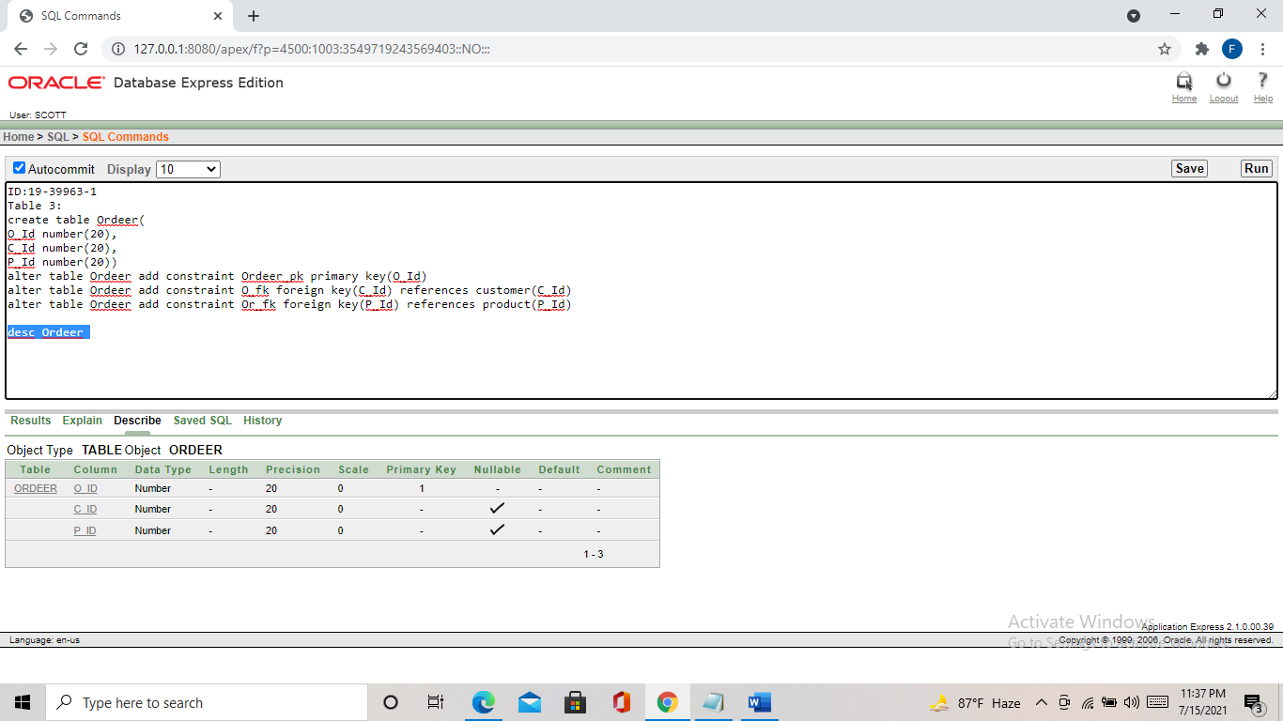

Table 4:

create table salesman(

S_Id number(20),

Name varchar(30),

Address varchar(40),

Join_Date date,

Phone_Number number(15))

alter table salesman add constraint salesman_pk primary key(S_Id)

create sequence s_seq

start with 10

increment by 1

maxvalue 1000

nocycle

nocache

desc salesman

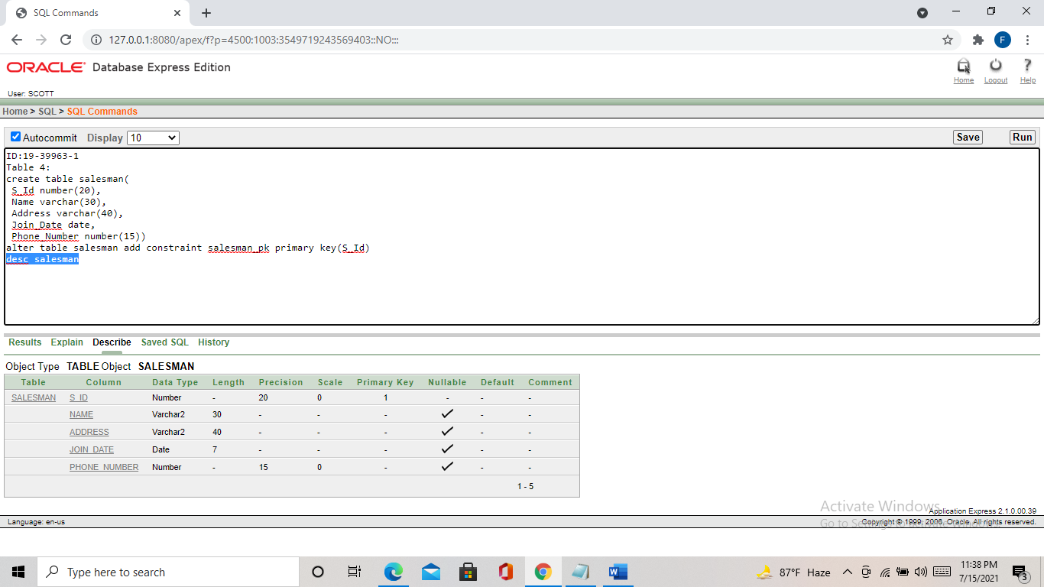

Table 5:

Create table Provide (

Pr_Id number(20),

S_Id number(20),

P_Id number(20))

alter table Provide add constraint P_pk primary key(Pr_Id)

alter table Provide add constraint P_fk foreign key(S_Id) references salesman(S_Id)

alter table Provide add constraint Pv_fk foreign key(P_Id) references Product(P_Id)

desc Provide

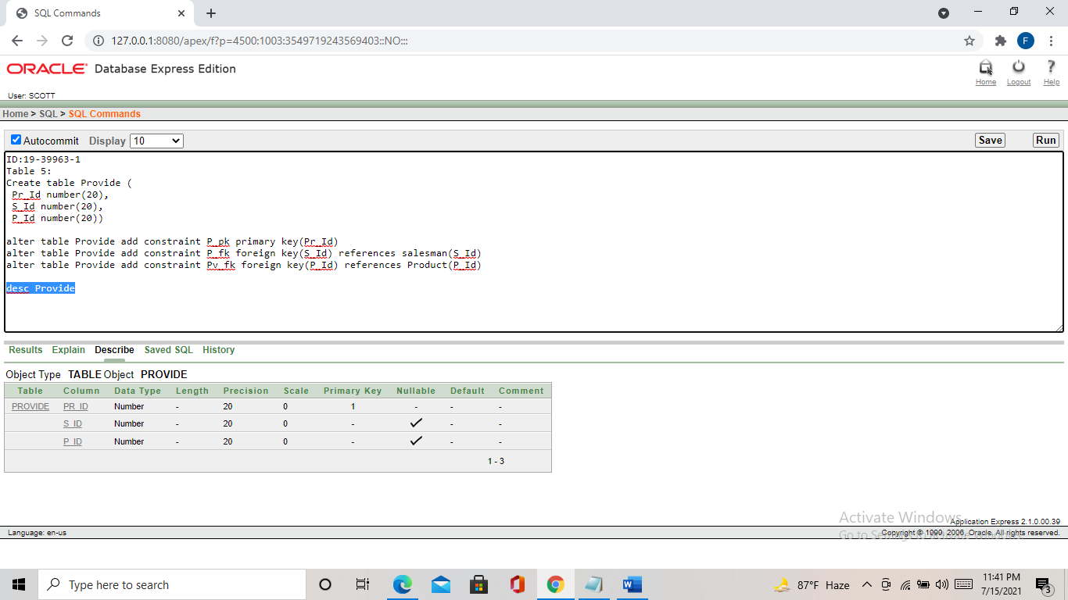

Table 6:

Create table Bill (

B_Id number(20),

Total_Bill decimal(7,6),

Transaction_Date Date,

Bill_Type decimal(7,6),

C_Id number(20))

alter table Bill add constraint Bill_pk primary key(B_Id)

alter table Bill add constraint B_fk foreign key(C_Id) references customer(C_Id)

desc Bill

drop table Bill

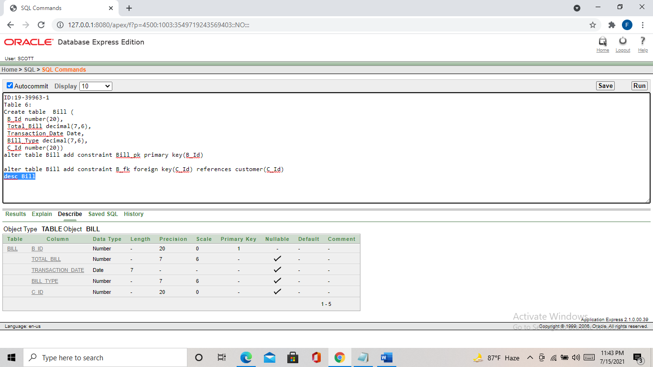

Table 7:

Create table Bill_Received (

B_Id number(20),

Total_Bill decimal(7,6),

Transaction_Date Date,

Bill_Type decimal(7,6),

Cashier_Id number(20))

alter table Bill_Received add constraint BR_pk primary key(B_Id)

alter table Bill_Received add constraint C_fk foreign key(Cashier_Id ) references Cashier (Cashier_Id )

desc Bill_Received

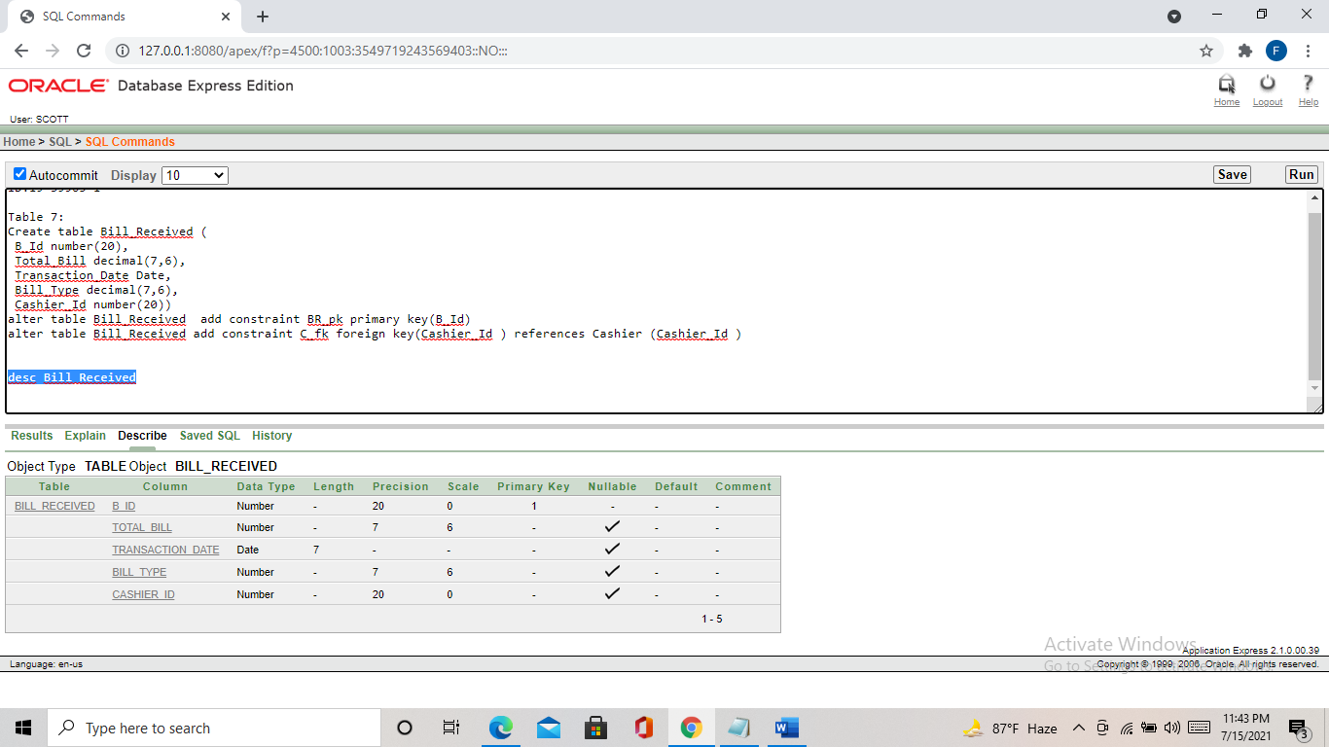

Table 8:

Create table Cashier (

Cashier_Id number(20),

Name varchar(30),

Gender varchar(10),

Address varchar(40),

Phone_Number number(15))

alter table Cashier add constraint Cashier_pk primary key(Cashier_Id )

desc Cashier

